Happy
Holiday’s!!

SEND A PERSONALIZED “WINTER CHARLIE GRAM” TO YOUR CHILD, GRANDCHILD, TEACHER, OR ANY FAVORITE PERSON!
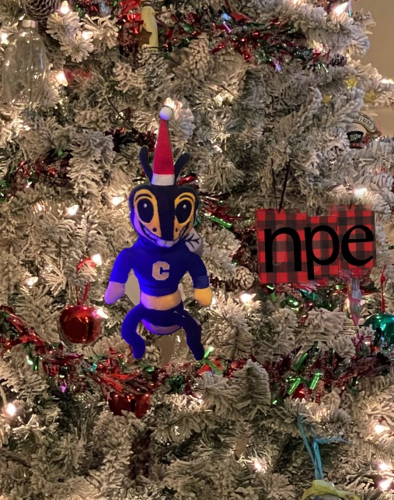
“Charlie Gram”
Includes Charlie plush, candy and personalized message
Delivered Friday, December 17th

$20 each
Due by December 13th
Send CASH or CHECK & Order form below!*
Please make checks payable to NPE PTO
* Cash App: $OKNPEPTO
************************************************************
1st Recipient: __________________________________________________________
Message: _____________________________________________________________
From: ___________________________ Class: _______________________________

2nd Recipient: __________________________________________________________
Message: _____________________________________________________________
From: ___________________________ Class: _______________________________
TOTAL AMOUNT ENCLOSED: ______________________________________________
CONTACT NAME:____________________ PHONE NUMBER: ____________________

